Branch – and – Bound

In branch-and-bound technique, for each node, bound value is calculated. The node’s bound value is compared with the value of the best solution seen so far. If the bound value is not better than the best solution seen so far, the node is said to be nonpromising and can be terminated, because no solution obtained form it can yield a better solution than the one already available.

A search path at the current node in a state-space tree of a branch-and-bound algorithm is terminated for any one of the following three reasons:
- The value of the node’s bound is not better than the value of the best solution seen so far.
- The node represents no feasible solutions because the constraints of the problem are already violated.
- The subset of feasible solutions represented by the node consists of a single point (and hence no further choices can be made)-in this case the value of the objective function for this feasible solution with that of the best solution seen so far is compared and the latter value with the former value is to be updated if the new solution is better.
Assignment Problem
Assigning n people to n jobs so that the total cost of the assignment is as small as possible.
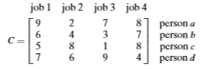
Cost of any solution, including an optimal one, cannot be smaller than the sum of the smallest elements in each of the matrix’s rows.
Initial lower bound:
lb = sum of the smallest elements in each of the matrix’s rows.
lb = 2 + 3 + 1 + 4
= 10
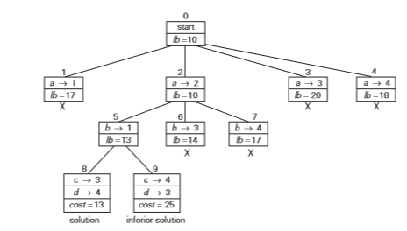
For node 1, we assume job1 is assigned to person a. When a job is assigned to a person, the same job cannot be assigned to other persons. The lower bound lb is calculated as,
lb = 9 + 3 + 1 +4
= 17
For node 2, we assume job2 is assigned to person a. The lower bound lb is calculated as,
lb = 2 + 3 + 1 +4
= 10
For node 3, we assume job3 is assigned to person a. The smallest value for person b and person c cannot be taken from the same column. The next smallest value for person b is 4, an d for person c is 5. The lower bound lb is calculated as,
lb = 7 + 4 + 5 +4
= 20
For node 4, we assume job4 is assigned to person a. The lower bound lb is calculated as,
lb = 8 + 3 + 1 + 6
= 18
After first level, the smallest lower bound is lb = 10, so, the job 2 is assigned to person a.

For node 5, we assume job 1 is assigned to person b. The lower bound lb is calculated as,
lb = 2 + 6 + 1 +4
= 13
For node 6, we assume job 3 is assigned to person b. The lower bound lb is calculated as,
lb = 2 + 3 + 5 +4
= 14
For node 7, we assume job 4 is assigned to person b. The lower bound lb is calculated as,
lb = 2 + 7 + 1 +7
= 17
After second level, the smallest lower bound is lb = 13, so, the job 1 is assigned to person b.

For node 8, we assume job 3 is assigned to person c and job 4 is assigned to person d. The lower bound lb is calculated as,
lb = 2 + 6 + 1 +4
= 13
For node 9, we assume job 4 is assigned to person c and job 3 is assigned to person d. The lower bound lb is calculated as,
lb = 2 + 6 + 8 +9
= 25
After third level, the smallest lower bound is lb = 13, so, the job 3 is assigned to person c, and the job 4 is assigned to person d.
Finally, jobs are assigned to persons as follows,
Job | Person | Cost
1 | b | 6
2 | a | 2
3 | c | 1
4 | d | 4
Total Cost |  | 13

Knapsack Problem
Given n items of known weights w_{i} and values v_{i}=1,2,3,...,n, and a knapsack of capacity W, find the most valuable subset of the items that fit in the knapsack.
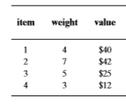
Step 1: find value / weight for all items and arrange the items in descending order by their value-to-weight ratios.
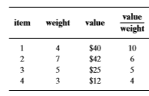
Step 2: The upper bound ub is calculated using the formula,
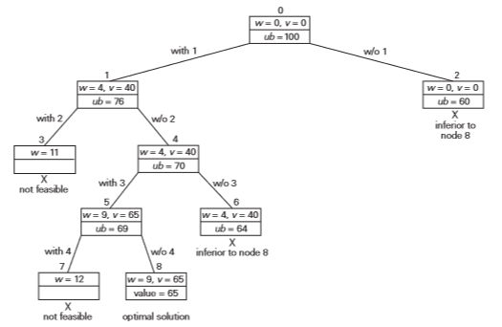
For node 0, no item is selected so far, w = 0, v = 0, the value/weight ratio of next item is item 1, therefore v_{i+1}/w_{i+1} = 10, the upper bound ub is calculated as,
ub = 0 + (10-0)*(10)
= 100

For node 1, assume item 1 is selected, its weight w = 4, value v = 40, and the value/weight ratio of next item is v_{i+1}/w_{i+1} = 6, the upper bound ub is calculated as,
ub = 40 + (10-4)*(6)
= 76
For node 2, assume item 1 is not selected, weight w = 0, value v = 0, and the value/weight ratio of next item is item 2, therefore, v_{i+1}/w_{i+1} = 6, the upper bound ub is calculated as,
ub = 0 + (10-0)*(6)
= 60
For node 3, assume item 2 is selected, its weight is w = 7, already item 1 is selected, weight of the item 1 is 4, if item 2 is selected, the total weight w = 4+7 = 11 is greater than the knapsack capacity W=10, so, this choice is considered not feasible.

For node 4, assume item 2 is not selected, weight w = 4, value v = 40 (already selected item1 weight and value), and the value/weight ratio of next item is item3, therefore, v_{i+1}/w_{i+1} = 5, the upper bound ub is calculated as,
ub = 40 + (10-4)*(5)
= 70

For node 5, assume item 3 is selected, its weight w = 5, value v = 25, (already selected item1 weight and value) now the total weight w = 4 + 5 = 9, v = 40 + 25 = 65, and the value/weight ratio of next item is item 4, therefore, v_{i+1}/w_{i+1} = 4, the upper bound ub is calculated as,
ub = 65 + (10-9)*(4)
= 69

For node 6, assume item 3 is not selected, now the total weight w = 4, v = 40, and the value/weight ratio of next item is item 4, therefore, v_{i+1}/w_{i+1} = 4, the upper bound ub is calculated as,
ub = 40 + (10-4)*(4)
= 64

Comparing the upper bound value of node 5 and node 6, node 5 has upper bound greater than node 6, so node 6 is considered as inferior.
For node 7, assume item 4 is selected, its weight is w = 3, already item 1 and item 3 is selected, weight of the item 1 is 4, weight of item 3 is 5, if item 4 is selected, the total weight becomes w = 4+5+3 = 12 is greater than the knapsack capacity W=10, so, this choice is considered not feasible.
For node 8, assume item 4 is not selected, already item 1 and item 3 is selected, weight of the item 1 is 4, weight of item 3 is 5, value of the item 1 is 40, value of item 3 is 25, if item 4 is not selected, the total weight becomes weight w = 4+5 = 9, v = 40+25 = 65, and the value/weight ratio of next item 0, therefore, v_{i+1}/w_{i+1} = 0, the upper bound ub is calculated as,
ub = 65 + (10-9)*(0)
= 65

Finally, selected items are as follows,
Item | weight | value
1 | 4 | 40
3 | 5 | 25
Total weight |  | 9
Total value |  | 65

Traveling Salesman Problem
To compute a lower bound on the length ‘l’ of any tour as follows. For each city, 1≤ i ≤ n, find the sum s_{i} of the distances from city i to the two nearest cities. Compute the sum s of these n cities, divide the result by 2, round up the result to the nearest integer.
The lower bound is computed as,
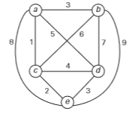
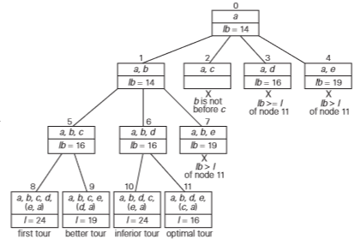
For node 0, the lower bound is calculated as follows,
For node 1, the edge a->b is selected, the lower bound is calculated as follows,
For node 2, the edge a->c is selected, the lower bound is calculated as follows,
For node 3, the edge a->d is selected, the lower bound is calculated as follows,
For node 4, the edge a->e is selected, the lower bound is calculated as follows,
After first level, the smallest lower bound is lb = 14, two edges a->b and a->c meets this value and the node b is before node c in chronological order, so the edge a->b is selected in the first level.
For node 5, the edge a->b and the edge b->c is selected, the lower bound is calculated as follows,
For node 6, the edge a->b and the edge b->d is selected, the lower bound is calculated as follows,
For node 7, the edge a->b and the edge b->e is selected, the lower bound is calculated as follows,
After second level, the smallest lower bound is lb = 16, two nodes, node 6 and node 7 meet this value and both the nodes are selected for further processing.
For node 8, the edges a->b, b->c, c->d, d->e, and e->a are selected, the lower bound is calculated as follows,
For node 9, the edges a->b, b->c, c->e, e->d, and d->a are selected, the lower bound is calculated as follows,
For node 10, the edges a->b, b->d, d->c, c->e, and e->a are selected, the lower bound is calculated as follows,
For node 11, the edges a->b, b->d, d->e, e->c, and c->a are selected, the lower bound is calculated as follows,
After third level, the smallest lower bound is lb = 16, the edges a->b, b->d, d->e, e->c, and c->a is considered as the optimal tour.
Finally, selected edges are as follows,
Edges | Cost
a->b | 3
b->d | 7
d->e | 3
e->c | 2
c->a | 1
Total Cost | 16

